

Luke H. Chatman
Memorial Scholarship
(African-American Males preferred)

2008 Application Packet

Contains:

Application
Instruction sheet
Recommendation Form (Brother)
Recommendation Form (Outside)
Rev. 2007-09-4

Biography of Brother Luke H. Chatman
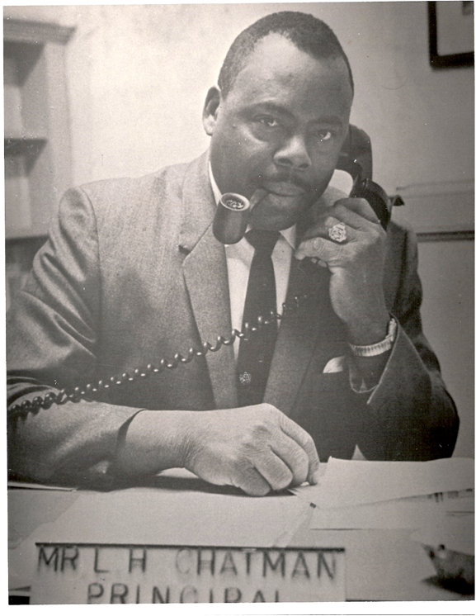

A Greenville native, Brother Luke Haze Chatman was born August 18, 1921. Having been reared in the public schools of Greenville County, Brother Chatman advanced his education by matriculating at South Carolina State University where he received his B.S. in Business and a M.S. in Education. A principal member of the Gamma Gamma Lambda Chapter, Brother Chatman served as President and Vice President as well as other chapter offices for many years.

In 1955, Brother Chatman became the first District Director for South Carolina. In 1968, he was elected Regional Vice President for the Southern Region of Alpha Phi Alpha Fraternity, Inc. A staunch defender of public education, Brother Chatman worked tirelessly to improve the educational system in Greenville County for more than 30 years.

Brother Chatman entered Omega Chapter (deceased) on June 20, 1985 and is survived by his wife Mrs. Janie Barksdale Chatman and three children, Mike (Alpha brother), Donna, and Glenda and two grandchildren.

History of Gamma Gamma Lambda Chapter

Gamma Gamma Lambda Chapter was chartered on August 24, 1941. From the ranks of the Chapter, have come several leaders in Alpha at the Area, Cluster, District, and Regional level. The Chapter is a proud member of the local National Pan Hellenic Council, Greenville Urban League, and makes contributions to the MLK Memorial Foundation, NAACP, Urban League, Phyllis Wheatley Community Center of Greenville, Multicultural Center of Greenville, United Negro College Fund, and March of Dimes.

For more view about the Chapter please visit our chapter web site at www.gglapa.org


History of Alpha Phi Alpha

Alpha Phi Alpha Fraternity, Inc. is the nation’s first Greek-letter fraternity established by African-American college students. Established on December 4, 1906 on the campus of Cornell University, Alpha Phi Alpha has more than 750 chapters worldwide with over 100,000 members.
GAMMA GAMMA LAMBDA CHAPTER OF ALPHA PHI ALPHA, INC.

APPLICATION FOR LUKE CHATMAN MEMORIAL SCHOLARSHIP
Please PRINT or TYPE. Fill out the form, completely
DEADLINE IS APRIL 1, 2008

APPLICANT NAME:
(Last) ( First ) ( Middle )

APPLICANT SSN: SEX: □ Male □ Female (check one)

APPLICANT ADDRESS:

CITY: STATE: ZIP CODE:

PHONE: DATE OF BIRTH: PLACE OF BIRTH

EMAIL ADDRESS (OPTIONAL):

Parent / Guardian Information

Name: □ Mr. □ Dr.
□ Mrs. □ Ms. □ Parent □ Guardian (check one)

MAILING ADDRESS:

CITY: STATE: ZIP CODE:

WORK PHONE: GRADE SUM GPR: scale: □ 4.0 □ 5.0 (Please check one)

Copy of Transcript Required SAT# ACT CLASS RANK: of

College / University Information

SEMESTER OF ENTRANCE: □ Summer 2008 □ Fall 2008 □ Spring 2009 (check one)
Applicant must enter school by January 15, 2009

COURSE OF STUDY DEGREE SOUGHT

EXPECTED COMPLETED DATE TERM STARTS

COST OF FEES /tuition per Semester: $

RETURN BY APRIL 1, 2008 to:

Scholarship Committee
Gamma Gamma Lambda Chapter APPLICANT SIGNTURE DATE
Alpha Phi Alpha Fraternity, Inc.
P.O. 5244
Greenville, SC 29606
www.gglapa.org
GAMMA GAMMA LAMBDA CHAPTER OF ALPHA PHI ALPHA, INC.

INSTRUCTIONS FOR COMPLETING THE APPLICATION
& APPLICATION CRITERIA
FILING DEADLINE IS APRIL 1, 2008

- Application must be completed by the applicant. Please type or print clearly (in black ink). You may add additional sheets provided the application includes all information requested.

- This scholarship is targeted for African-American students who attend a public High School in Greenville County. African-American Males are preferred.

- Attach the following to the completed application:

  - Two letters of reference. Both must be from an older adult in the local community, not related to the applicant. If one or more is from a member of Alpha Phi Alpha Fraternity, that application will be given preference. See the attached forms for more details.
  - Certified copy of the transcript of courses completed through first semester of the senior year (including a SAT or ACT score)
  - A biographical statement, including educational background, civic and projects and other pertinent information on yourself.
  - An Essay, on a separate sheet of paper write (print or type), double-spaced and no more than 2 pages long,on the following topic:

“How this scholarship will help me pursue my career goals”

  - The committee must be received the application along with a certified copy of your high school transcript on or before April 1, 2008.

- The scholarship applicant must be willing to appear before the Scholarship Committee for a personal interview, if such an interview is requested.

- Applicants will be judged on the basis of their secondary school records, personal qualifications, and results of SAT/ACT test, and the strength of recommendations.

- Scholarship recipient must attend an accredited college of his or her choice by January 15, 2008. Applicants must gain admission to the college/university, and maintain enrollment each of the following years of the scholarship.

- The amount of the scholarship will be deposited with the college or university attended by the student. When the recipient notifies the Scholarship Committee in writing that he or she is enrolled, the amount of the scholarship will be sent to the business office to be applied to the cost of tuition, room, and board. Exceptions to this rule can be considered by the committee and must be submitted in writing in due time for the committee’s review.

- Send completed application packet to:

Scholarship Committee
Gamma Gamma Lambda Chapter
Alpha Phi Alpha Fraternity, Inc.
P.O. Box 5244
Greenville, S.C. 29606

APPLICATIONS MUST BE RECEIVED BY APRIL 1, 2008
GAMMA GAMMA LAMBDA CHAPTER OF ALPHA PHI ALPHA, INC.

SPONSORSHIP FOR LUKE CHATMAN SCHOLARSHIP
(From a member of Alpha Phi Alpha)
You may attach a letter to this form. Please return by April 1, 2008.

APPLICANT NAME:
(Last) ( First ) ( Middle )

REFERENCE NAME:
(Last) ( First ) ( Middle )

PHONE: Home/work
(Home Number) (Work Phone)

MAILING ADDR:

(City) (State) ( Zip Code )

CHAPTER INFO:
(Chapter) (Seat) (Key # / Initiation Date )

Do you attest based upon personal knowledge, information and belief that the applicant possesses the personal character and moral reputation desired to receive this scholarship?

□ Yes □ No Please explain and comment: (You may attach a sheet)
Please check one

Do you know any special situations, circumstances, or special needs we should consider with this applicant’s personal character and moral reputation desired to receive this scholarship?

□ Yes □ No Please explain and comment: (You may attach a sheet)
Please check one

How long have you known the Applicant?
(Please indicate timeframe in years or months.)

Explain how you are acquainted with the applicant and describe the applicant’s involvement in school activities or community, professional and civic activities:

I HEREBY CERTIFY AND ATTEST that the foregoing information provided by me is true and to the best of my knowledge, information and belief. I certify that I am in good standing with the Fraternity. I understand my obligation to the Fraternity to exercise due diligence in making this recommendation for membership. Without reservation, I recommend the applicant for the LUKE CHATMAN SCHOLARSHIP.
I certify that this brother is in good standing with the National Organization and our Chapter.

Financial Secretary, ________ Chapter
(Reference Signature) (Date)

GAMMA GAMMA LAMBDA CHAPTER OF ALPHA PHI ALPHA, INC.

SPONSORSHIP FOR LUKE CHATMAN SCHOLARSHIP
(Outside Reference)
You may attach a letter to this form. Please return by April 1, 2008.

APPLICANT NAME:
(Last) ( First ) ( Middle )

REFERENCE NAME:
(Last) ( First ) ( Middle )

PHONE: Home / Work
(Home Phone) (Work Phone)

MAILING ADDR:

(City) (State) ( Zip Code )

OCCUPTION / CO.
(Position) (Company) (Years at Co.)

Do you attest based upon personal knowledge, information and belief that the applicant possesses the personal character and moral reputation desired to receive this scholarship?

□ Yes □ No Please explain and comment: (You may attach a sheet)
Please check one

Do you know any special situations, circumstances, or special needs we should consider with this applicant’s personal character and moral reputation desired to receive this scholarship?

□ Yes □ No Please explain and comment: (You may attach a sheet)
Please check one

How long have you known the Applicant?
(Please indicate timeframe in years or months.)

Explain how you are acquainted with the applicant and describe the applicant’s involvement in school activities or community, professional and civic activities:

I HEREBY CERTIFY AND ATTEST that the foregoing information provided by me is true and to the best of my knowledge, information and belief. Without reservation, I recommend the applicant for the LUKE CHATMAN SCHOLARSHIP. I attest that to the best of my knowledge and belief that the aspirant is worthy, well qualified and well suited candidate for the scholarship.

(Reference Signature) (Date)

